JOIN NOW!
FIREFIGHTER/EMS VENTURING CREW

Learn what it takes to make it in the exciting field of Firefighter and Emergency Medical Services (EMS).
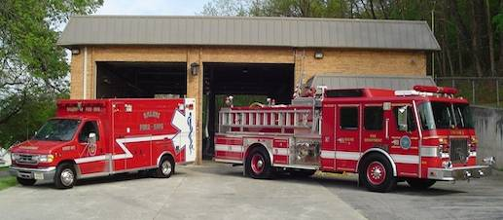

Venturing offers young men and women,
ages 14-20,
the chance to experience Firefighter and Emergency Medical Service (EMS) career opportunities.
www.tcfea.com
651-269-4782

Sponsored by the Twin Cities Fire Engine Association

